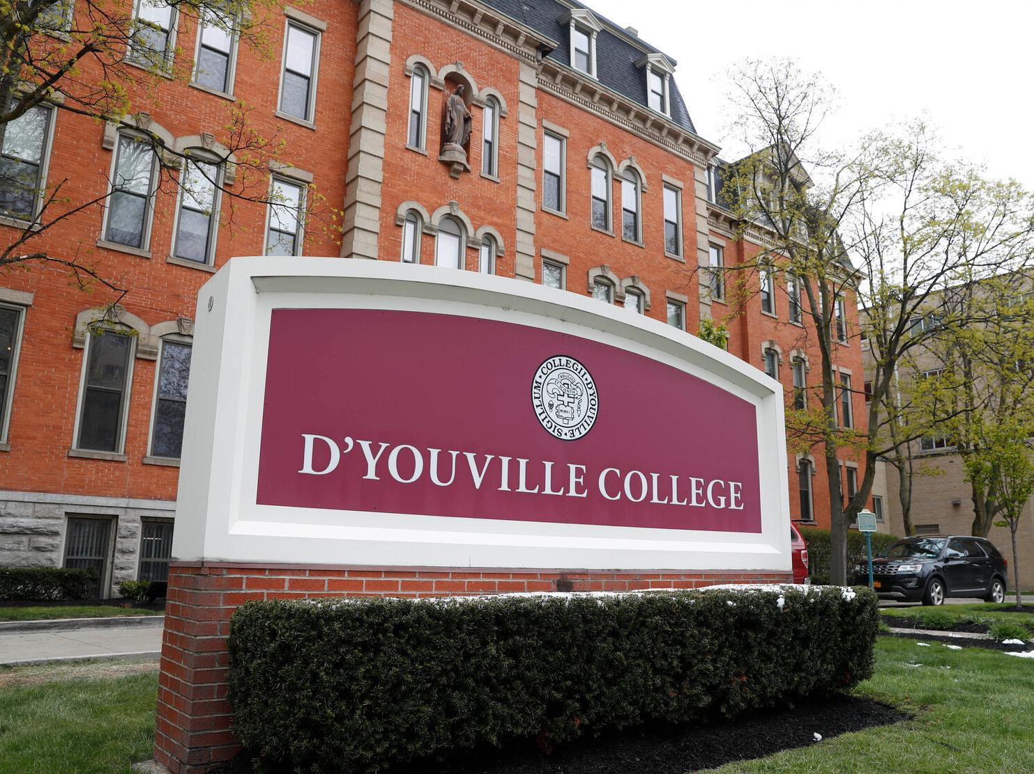

MINIMUM CAPACITY :-

The Minumum intake capacity

of students is between 150-350

children

LIBRARY :-

The Libarary is Available.

CANTEEN:-

The Canteen Facility is Available.

BOARDING :-

No availablility of boarding.

SPORTS :-

There are different categories

sports available.

Girls Volleyball

Boys Volleyball

Football

|  |  |  |
| --- | --- | --- |
| D'YOUVILLE COLLEGE  BUFFALO - SCHOOL |  |  |
|  |  |  |
| School Detail :- D'Youville University is a private university in Buffalo, New York. It was founded as D'Youville College in 1908 and named by the Grey Nuns after the patroness saint Marie-Marguerite d'Youville.  Located in [Western New York](https://en.wikipedia.org/wiki/Western_New_York) on the [Lower West Side](https://en.wikipedia.org/wiki/Lower_West_Side,_Buffalo) of the [City of Buffalo](https://en.wikipedia.org/wiki/Buffalo,_New_York), the campus is in an urban setting a few blocks from the [Peace Bridge](https://en.wikipedia.org/wiki/Peace_Bridge) on the Canadian border. The campus has 15 buildings with classrooms, laboratories, residential and athletics facilities. There are two student housing buildings and one outdoor athletics complex. |  |
|